GOLD MEDAL – AWARDED PRODUCTS HOME DECOR 2020

- Cameleon System
NOWODWORSKI Sp. j.

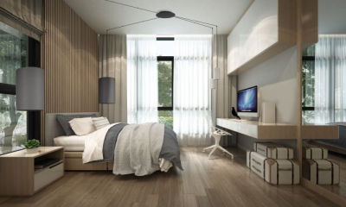
Cameleon system produced by Nowodvorski Lighting enables users to design lighting according their individual preferences and needs. The user may create own lighting system by selecting: shade, suspension system, installation box and mounting accessories. All elements are presented in the catalogue of Cameleon system, which contains the necessary installation instructions to help users to design and install their own lighting systems.

- HUG ME – upholstery fabric from Toccare Collections by Dymitr Malcew
Agmamito Group / AGMAMITO Jacek Siekacz Sp. z o.o.

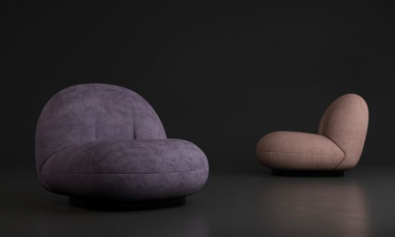
HUG ME collection is an innovative double-side nubuck, extremely pleasant to the touch, gentle, but very durable. HUG ME joins two opposites - a timeless simplicity of nubuck texture and uniqueness of colour patterns. HUG ME is extremely soft and pleasant to the touch - it makes every user to feel comfortable. Additionally, it is easy to keep clean. With WATER BLOCKED system, all spilled liquids do not penetrate deep into the fabric.

- Laguna Aqua carpet from Carpet Decor
FARGOTEX Sp. z o.o.
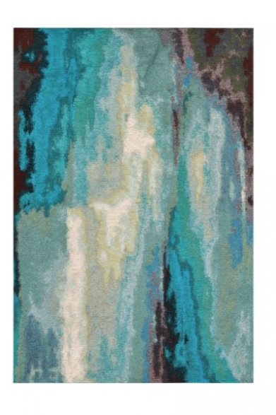
Laguna Aqua is a modern carpet of Carper Decor brand offered by Fargotex Decor Its unique pattern will look great in almost any interior. The carpet draws attention to its modern and original design. Deep colours will bring positive energy into any room. It is an offer for people who appreciate original design and functionality at the same time. Its easy-clean properties make the carpet really user-friendly, without compromising its unique structure. The non-slip backing of the carpet helps to keep it in desired place, without unnecessary shifting. Allergy-free and environmentally friendly. It is very pleasant to the touch and its unique patterns and shades make it really decorative. It looks great in bedrooms, living rooms and offices.

- TOUCH ME – upholstery fabric from Toccare Collections by Dymitr Malcew
Agmamito Group / AGMAMITO Jacek Siekacz Sp. z o.o.

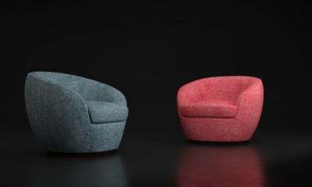
TOUCH ME is a perfect fusion of design, comfort and tactile properties, guaranteeing freedom in designing space and furniture arrangement. The perfect combination of matt threads with glossy fabric creates a three-dimensional effect. The fabric surface reflects light and creates a gentle sparkling effect with countless tiny flashes. TOUCH ME looks especially attractive with simple blocks of furniture. It is soft and pleasant to the touch, ensuring maximum use comfort.
- ZOYA - easy-clean fabric Magic Home Collection
FARGOTEX Sp. z o.o.

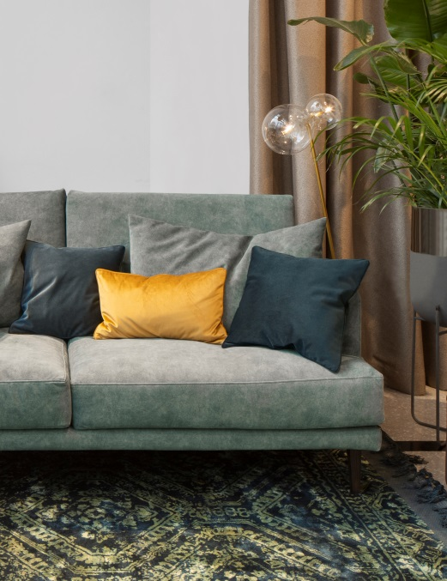
ZOYA is a high quality knitted fabric, which combines sophisticated design and excellent technical parameters. Beautiful colours are enriched with subtle and elegant vintage effect. It is suitable for using both as an upholstery and decorative fabric. You may use it to create beautiful cushions or curtains. Zoya will satisfy those who appreciate unique style, but it will also delight those who prefer functionality and comfort. It is recommended both families with children and for pet owners, due to its easy-clean technology and increased resistance to damage.

